**How to Solve the Rubik’s Cube**

***Overview***

There are many ways to solve the Rubik’s Cube. World record holders learned the fast way, but I can teach you the long yet sufficient way to solve it. People think it’s a mathematical equation that you must learn to solve it but that’s false. If you take it slowly following the steps, it’ll be safer. This is one way to impress your friends and with enough practice, it’ll be a piece of cake. Don’t worry, it’s not as hard as you think!

***Introduction***

These instructions will show you step by step how to solve the Rubik’s Cube. If you get stuck be sure to look at the photos provided… Some steps may repeat themselves depending on the step you are on. Pay close to attention to each and every scenario shown possible. If needed, go backwards. Each side of the cube will be named but only from your point of view and arrows will be provided to show which way you’re supposed to turn that specific side. Meaning, if you’re looking at the cube facing the blue side (white above and yellow below), your right-hand side (orange) would be R1, and your left-hand side (red) would be L1. Pictures will be provided for clarity. Some cubes may vary by color placement, I’m going by the original.

***Sides to learn***

This is a basic white cube with indicators of what the sides will be referred as in the written instructions. This is all based on how you’re looking at the cube at any angle. F1 is the color in front of you. Hence Face 1.

B1

T1

L1

F2

F1

R1

Here are the same labels but on a flat and open cube in case the arrows were unclear:

F2

B1

L1

R1

T1

F1

***Step 1***

The first step to solving the Rubik’s Cube is making a cross on the white side of the cube with its edge pieces while keeping an eye on the center colors around it (red, green, blue, orange). You must match the white side of the cross to the correct center color on the side. So, if you have a white-blue edge piece, you must place it between the white and blue sides as so:

Edge piece

Once you have your edge pieces matching the center colors accordingly, you must put the white corner pieces together. They must go according to the side colors once again. In the previous picture, the white, blue, and orange corner piece is supposed to be there, but it must be flipped so the white can face up. Do that for every corner.

Congratulations! You have one side completed! Now, your cube should have a small T going all around the cube just like the blue and orange side shown above.

***Step 2***

From here on out, I will provide the moves that are required to finish the cube. Thus far, the moves have been open ended and they all depend on how you mixed up the cube. Our next step is to match the center edge pieces, for example the blue-orange edge piece or the blue and red piece. To do so you are required to look at how your Rubik’s Cube is set up at this point. It may look different, but the concept is the same. Going by my cube, I see that the red-green edge piece is not in place. What you need to do is look at what color is facing the yellow side. For me, the green edge side is on the yellow side, which means that I need to twist the B1 side opposite of the green side. B1 in this scenario is the yellow side, since it is the bottom. Once the edge piece is away from the green side, you must face the green side, which means the white would be on top (T1), red on the right (R1), and orange on the left (L1). In this scenario the edge piece needs to go on the right-hand side from my point of view. The moves to getting that edge piece in place is as followed: **R1↓, B1→, R1↑, B1 →→, R1↓, B1→, R1↑, B1→, R1↓, B1 ←, R1↑.** If you are faced with an edge piece that needs to be placed on the left-hand side, do the same steps but on the left side instead, turning it the opposite direction; **L1↓, B1←, L1↑, B1 ←←, L1↓, B1←, L1↑, B1←, L1↓, B1 →, L1↑.** Do that for each side until you have 2 layers done.

***Step 3***For this step, you must look at the yellow side of the cube to make a yellow cross. The same one you did for the first step on the white side. However, this step differs with the number of times you might have to do it to complete it. If your yellow side has edge pieces on it already, you might only have to do this once. My cube currently has no yellow edge pieces in place, so it doesn’t matter how I face the cube. In this case, I’m choosing the red side to be my F1 and again, the blue side is R1, green is L1, and white is T1. The moves to make the yellow a cross are: **R1 and L1↑ together, F1→, R1 and L1↓ together, B1→, R1 and L1↑ together, F1→, R1 and L1↓ together, B1→, R1 and L1↑ together, F1→, R1 and L1↓ together.** Now I have only 2 edge pieces together (they don’t have to align with the side center pieces like we did in the beginning). To finish off the cross, look at the yellow side. If 2 of the missing colors are next to each other, it’ll only take one more step to complete that cross.

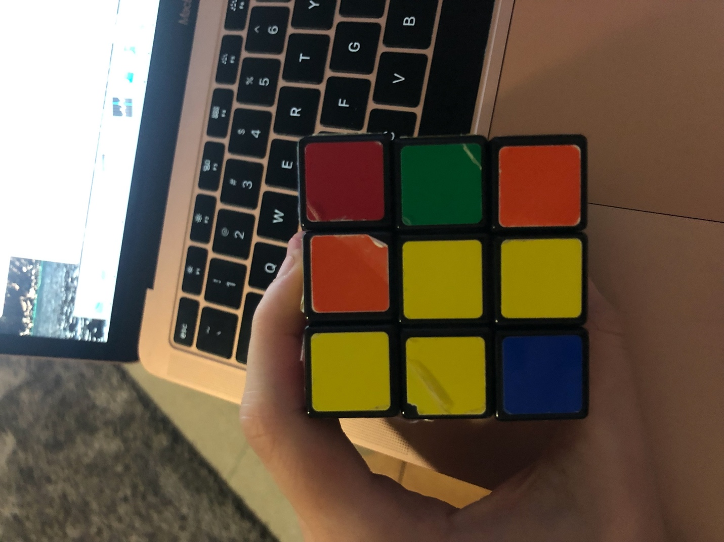

2 missing yellow colors next to each other

Based off the picture provided, the orange square that will be changed to yellow should be at the top and the other non-yellow square should be on the right side. This is how the 2 squares are supposed to be set up. Once you’ve figured that out, look at the cube in the way that the top square is towards you. For me, the blue side is facing me now. From here you can repeat the same steps as before to finish the cross.

***Step 4***

Your cross might consist of 2,3, maybe even 4 yellow corners but don’t worry about them right now. They’ll come in play later. What you need to pay attention to is if the corners correlate to the sides they need to be at. No matter the direction of the corner piece, it needs to be ready to be flipped. For example, if you take the green-red-yellow corner piece and align it with the green-red-yellow side it would match. But if you check the rest of the corners and they don’t match, you must flip them in this step. In my case the green-red-yellow and the blue-red-yellow corners match but the rest do not. To fix this, have both mismatching corners be on your right-hand side while the rest are matching and face it as the white is on top. The simple fix is: **L1↓, B1←, R1↓, B1→, L1↑, B1←, R1↑.** Now, all the corners should be at their assigned position. Match to check.

Now’s the time to get only one yellow corner on the yellow side. You might already have one, in that case skip this step. If you have more or less than 1 yellow corner, you’ll need to do this step. I currently have 2 yellow corners on the yellow side and 2 other ones on one side.

By facing the orange side, the moves you need to make are: **R1↓, B1→→, R1↑, B1→, R1↓, B1→, R1↑.** Repeat this step if needed.

***Step 5***

Now that you have one yellow corner on your yellow side, we will proceed with the last couple of steps to solving the Rubik’s Cube! Align the corners accordingly again by color. Now look at the yellow side of the cube and hold it so the yellow corner will be on the top left side as so:

Hold the cube so the yellow is at the bottom now but let the yellow corner point at you. To begin you must turn B1 (yellow) twice and after that you repeat the previous moves, so it goes: **B1→→, R1↓, B1→→, R1↑, B1→, R1↓, B1→, R1↑.** Repeat this step if needed. Now your cube might look something like this:

You will have 3 sides that are uncomplete because of one bottom edge piece. Sometimes you might have 4 but never 2. To solve this, you must face the side that is in between 2 uncomplete sides (the side in-between should also have one incomplete edge piece). The side I’m using is the green side and I see that the edge piece on the green side is orange. What you need to do is turn **F1** completely upside and then turn **B1** in the direction that your edge piece is colored, so I’d turn it towards the orange side. Then it goes in this sequence every time: **R1 and L1↑ together, F1→→, R1 and L1↓ together, B1 align it with its according color, F1→→.**

And there you go! You’ve solved the Rubik’s Cube!

